



Pharmacy Management System
Project Team Members:
- Ahmed Salah Farouk
- Ahmed Mamdouh Sadek
- Mohamed Assem Ahmed
- Seif El-Din Khaled Nazmy
- Reem Adel

Supervised By
Dr. Nancy

Preface
This Software Requirements Specification (SRS) document provides a comprehensive description of the Pharmacy Management System requirements. It is intended to guide stakeholders, including developers, testers, and project managers, in understanding the necessary functionalities and constraints of the system. This document ensures clarity and consensus on what the system should achieve, serving as a foundation for design, development, and validation phases.

Document Purpose
The purpose of this SRS is to clearly define the requirements of the Pharmacy Management System without delving into design or implementation details. It establishes a common understanding among stakeholders regarding the functional and non-functional requirements of the system. This document will be used as a reference throughout the software development lifecycle to ensure that the final product meets the defined expectations.

Target Users
The intended audience for this SRS includes:
- Project Managers – to understand the scope, constraints, and deliverables of the project.
- Software Developers – to develop the system according to clearly defined functional and non-functional requirements.
- Testers / QA Engineers – to validate that the system meets the specified requirements.
- Stakeholders / Pharmacy Staff – to review and confirm that the system will fulfill operational needs.

Introduction

Purpose
The purpose of the Pharmacy Management System is to streamline and automate the operations of a pharmacy, including inventory management, sales processing, prescription tracking, and customer management. The software aims to reduce manual errors, improve efficiency, and ensure accurate record-keeping for both the pharmacy staff and management.

Scope
The Pharmacy Management System is designed to:
- Maintain an up-to-date inventory of medicines and medical supplies.
- Automate the sales process and generate invoices for customers
- Provide reports on sales, inventory status, and expiry tracking.
- Enhance customer service by storing customer history and preferences.

Benefits:
- Increased operational efficiency and reduced manual workload.
- Minimized errors in inventory and sales management.
- Better decision-making through real-time reporting.
- Improved customer satisfaction with faster service and accurate records.

Overview
This SRS document is organized as follows:
- Preface – Provides the purpose of the document, identifies the target users, and includes the revision history.
- Introduction – Describes the purpose, scope, and benefits of the Pharmacy Management System.
- System Requirements – Details both the functional and non-functional requirements of the system.
- Use Cases – Illustrates how the system interacts with different types of users to perform its functions.
- Design Constraints – Lists the limitations, standards, and regulations that the system must adhere to.
- Appendices – Includes supplementary information such as the glossary, sample I/O formats, cost analysis, and references.

Glossary
Term / Acronym | Definition
SRS | Software Requirements Specification: a document that describes the functionalities, constraints, and requirements of a software system.
Pharmacy Management System (PMS) | A software application designed to manage pharmacy operations including inventory, sales, prescriptions, and customer management.
Inventory | The list of medicines and medical supplies stored in the pharmacy, including details like quantity, expiry date, and batch number.
Invoice | A document generated by the system that records details of a sale, including purchased items, quantity, price, and total amount.
User | Any individual interacting with the system, including pharmacy staff, managers, and customers.
Non-functional Requirements (NFRs) | System attributes such as performance, security, reliability, and usability that define how the system operates rather than what it does.
Functional Requirements (FRs) | Specific features or functions that the system must provide, like adding medicines to inventory or generating sales reports.
Admin | A user with full access to the system, able to manage inventory, users, and reports.
Cashier | A user responsible for handling sales transactions and customer billing.
Expiry Tracking | A system feature that monitors medicine expiry dates and alerts users before items expire.

System Users
ID | User Type | Characteristics | Responsibilities / Objectives
SU1 | Administrator (Admin) | Highly trusted personnel with full access to the system. | Manage users, update inventory, generate reports, monitor system performance, ensure overall system security, and support decision-making.
SU2 | Pharmacist | Licensed pharmacy staff responsible for dispensing medicines and advising customers. | check medicine availability, update inventory levels, maintain patient records, and provide better customer service.
SU3 | Cashier | Staff responsible for handling sales transactions. | Generate invoices, handle payments, manage customer billing, provide receipts, and ensure fast and accurate sales processing.
SU4 | Customer | End users of the pharmacy who purchase medicines and consult pharmacy staff. | Request medicines, receive invoices, and complete purchases efficiently.
SU5 | System Developer / IT Support | Technical personnel responsible for maintaining and updating the system. | Ensure smooth system operation, implement updates, fix bugs, maintain system reliability, and support functional/non-functional requirements.

System Functions
The Pharmacy Management System will perform the following high-level functions:
- Inventory Management
  - Maintain a real-time record of all medicines and medical supplies.
  - Track stock levels, batch numbers, and expiry dates.
- Order Management
  - Manage supplier orders for medicines and medical supplies.
  - Track order status (pending, shipped, delivered).
  - Update inventory automatically upon receiving new stock.
- Medicine Dispensing Management
  - Ensure accurate dispensing of medicines to customers.
  - Verify dosage and quantity according to prescriptions or standard guidelines.
  - Record dispensing history for future reference and compliance.
- Reporting and Analytics
  - Generate daily, weekly, and monthly inventory and sales reports.
  - Provide insights into stock trends and near-expiry medicines.
  - Support management in decision-making and operational efficiency.
- User Management
  - Create, update, and delete user accounts (Admin, Pharmacist, Cashier).
  - Assign appropriate roles and access levels to different users.
  - Monitor user activity and maintain audit logs.
- Customer Management
  - Maintain a database of customer information and purchase history.
  - Enable personalized services and faster transactions.

Constraints
The design and implementation of the Pharmacy Management System are subject to the following constraints:
- Hardware Limitations: The system must operate efficiently on standard computers available at the pharmacy. No specialized hardware is required.
- Software Standards: Must comply with relevant software standards for database management, user interface, and security protocols.
- Regulatory Compliance: The system must adhere to medical and pharmaceutical regulations, including prescription handling and patient data privacy.
- Company Policies: Must follow internal pharmacy policies regarding access control, data retention, and reporting standards.
- Performance Constraints: The system should process sales and inventory updates in real-time without noticeable delays.
- Security Constraints: Sensitive data, such as customer records and prescription details, must be protected through authentication and authorization mechanisms.

System Architecture

High-Level Overview
The Pharmacy Management System follows a three-tier architecture consisting of:
- Presentation Layer (User Interface)
  - This layer provides the interface for system users (Admin, Pharmacist, Cashier).
  - Handles user interactions, input forms, and display of information such as inventory lists, sales invoices, and reports.
- Business Logic Layer (Application Layer)
  - Contains the core functionality of the system.
  - Processes user requests, manages inventory, and calculates sales totals.
  - Implements rules for user roles, permissions, and workflow processes.

- Data Layer (Database Layer)
  - Stores all information related to medicines, prescriptions, sales transactions, customers, and users.
  - Ensures data integrity, consistency, and security.
  - Communicates with the business logic layer to retrieve or update data as required.

Key Features of the Architecture:
- Modular design: Each layer can be maintained or upgraded independently.
- Secure access: User roles determine access to system features.
- Scalability: Can be extended to include more users, branches, or advanced reporting features in the future.

System Functional Requirements
ID | Functional Requirement | Description
FR1 | Add New Medicine | Allow Admin or Pharmacist to add new medicines with details like name, category, batch, quantity, prices, and expiry date.
FR2 | Update Medicine Details | Allow updating existing medicine information, including stock quantity, prices, and expiration.
FR3 | Delete Medicine | Allow deletion of expired or discontinued medicines from inventory.
FR4 | Search Medicine | Customers can search medicines by name or category.
FR5 | View Product Details | Show price, description, stock, and expiry date.
FR6 | Shopping Cart | Customers can add items and proceed to checkout.
FR7 | Sales History | Maintain a record of all sales transactions for reporting purposes.
FR8 | Create User Accounts | Allow Admin to create new user accounts with defined roles (Admin, Pharmacist, Cashier).
FR9 | Update User Details | Allow Admin to update user information and access permissions.
FR10 | Delete User Accounts | Allow Admin to remove users who no longer require access.
FR11 | Authentication | Require login credentials to access functionalities according to user roles.
FR12 | Add Customer Information | Store customer details including name, contact information, and medical history if available.
FR13 | Manage Orders | Admin can view and update order status
FR14 | Manage Suppliers | Admin can add and edit supplier info.
FR15 | Inventory Report | Generate reports showing current stock levels, low stock alerts, and expired items.
FR16 | Sales Report | Provide daily, weekly, and monthly sales reports.

Interface Requirements Table
ID | Interface Type | Description
IR1 | User Interface | GUI with navigation menu, main workspace, and status bar. Standard buttons: Add, Edit, Delete, Save, Cancel, Search, Print.
IR3 | User Interface | Error messages: Clear, concise, indicate corrective action (e.g., “Stock quantity cannot be negative”).
IR4 | User Interface | Sample screens: Dashboard (sales overview, inventory alerts), Inventory screen (search/filter table), Sales screen (invoice form).
IR5 | Hardware Interface | Supported devices: Desktop PCs, POS terminals, barcode scanners, receipt printers.
IR6 | Hardware Interface | Data & control interactions: Barcode scanner reads medicine codes; receipt printer generates invoices.
IR7 | Hardware Interface | Communication protocols: USB or Serial for peripherals, TCP/IP for networked devices.
IR8 | Software Interface | Database connection: Relational database (MySQL/PostgreSQL) for medicines, sales, users, customers.
IR9 | Software Interface | Operating systems: Compatible with Windows and Linux.
IR10 | Software Interface | Libraries & tools: Frontend (Bootstrap/React), Backend (Laravel/Django), Reporting.
IR11 | Software Interface | Data exchanged: Input (user forms); Output (invoices, reports).
IR14 | Communication Interface | Data transfer & synchronization: Real-time updates across terminals; auto-sync for multi-terminal setups.

Non-Functional Requirements Table
ID | Requirement Type | Description
NFR1 | Performance | The system shall process sales transactions and update inventory in real-time with minimal delay.
NFR2 | Reliability | The system shall ensure 99% uptime and prevent data loss during operations.
NFR3 | Availability | The system shall be available to authorized users 24/7 during working hours, with backup access if needed.
NFR4 | Security | The system shall provide role-based access control, and secure storage of sensitive data.
NFR5 | Usability | The system shall have an intuitive GUI, consistent navigation, and provide help/tooltips for all functionalities.
NFR6 | Maintainability | The system shall be modular and allow easy updates, bug fixes, and addition of new features.
NFR7 | Scalability | The system shall support an increasing number of users, sales transactions, and inventory items without performance degradation.
NFR8 | Compatibility | The system shall be compatible with standard desktop PCs, Windows and Linux OS, barcode scanners, and receipt printers.
NFR9 | Regulatory Compliance | The system shall comply with medical, pharmaceutical, and data privacy regulations relevant to pharmacy operations.
NFR10 | Response Time | The system shall respond to user actions (e.g., search, add medicine) within 2 seconds under normal load.
NFR11 | Audit & Logging | The system shall maintain logs for user activities, sales, inventory changes, and system errors for auditing purposes.

System Models and Diagrams

1. Use Case Diagram
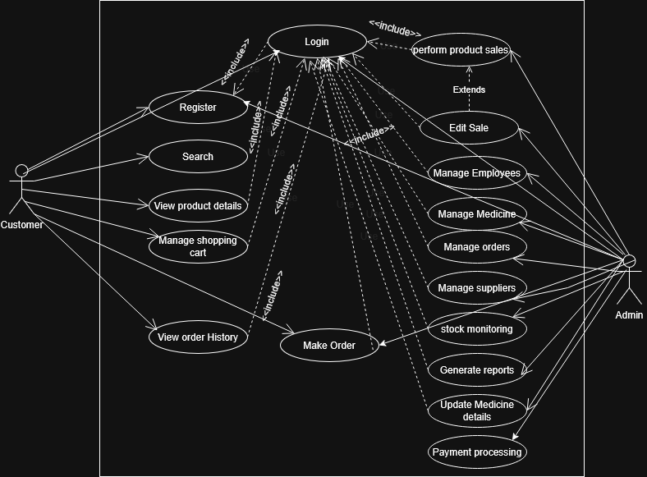
Description:
The Use Case Diagram represents the main functionalities of the system and the interaction between users and the system. It highlights the system’s behavior from the users’ perspective.
Figure 1: Use Case Diagram

2. Entity Relationship Diagram (ERD)
Description:
The Entity Relationship Diagram (ERD) illustrates the database structure of the Pharmacy Management System. It shows the main entities, their attributes, and the relationships between them, including primary keys and foreign keys. This diagram helps in understanding how data is stored and related within the system.

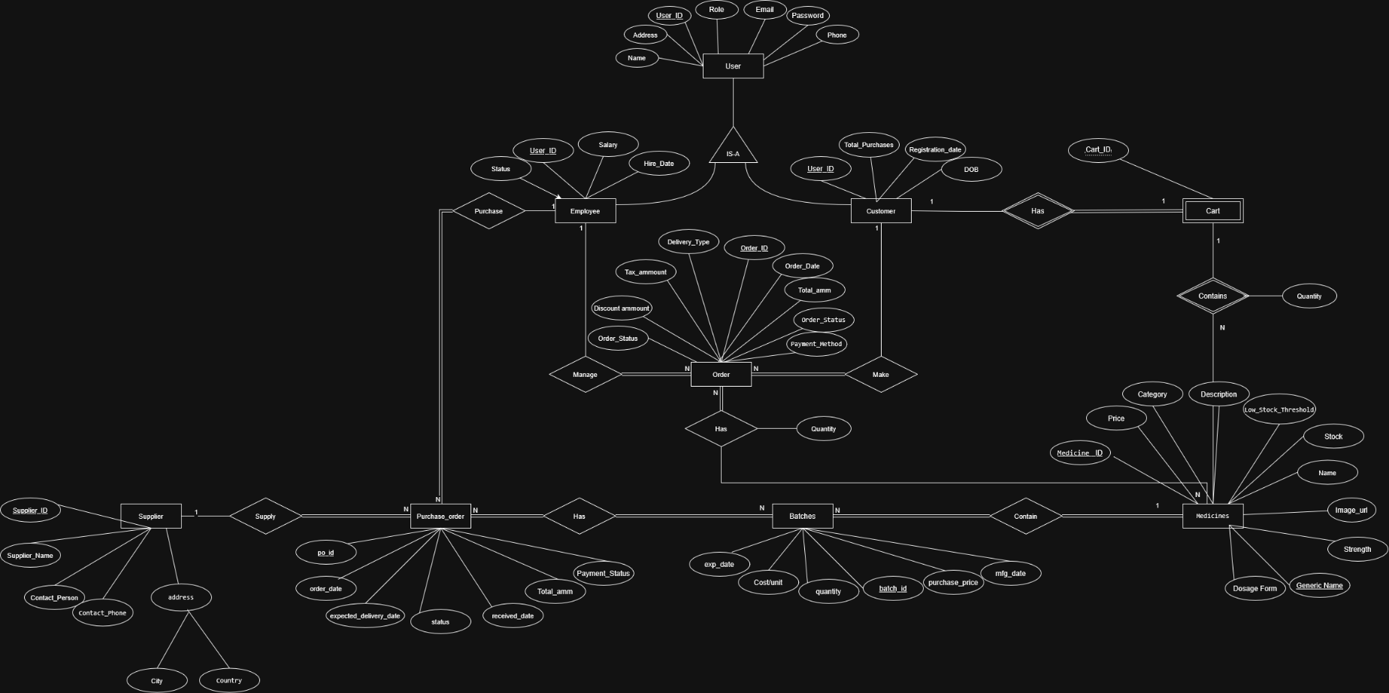

Figure 2: Entity Relationship Diagram (ERD)

3. Class Diagram-MVC Architecture
Description:
The Class Diagram shows the static structure of the system, including the main classes, their attributes, methods, and relationships.

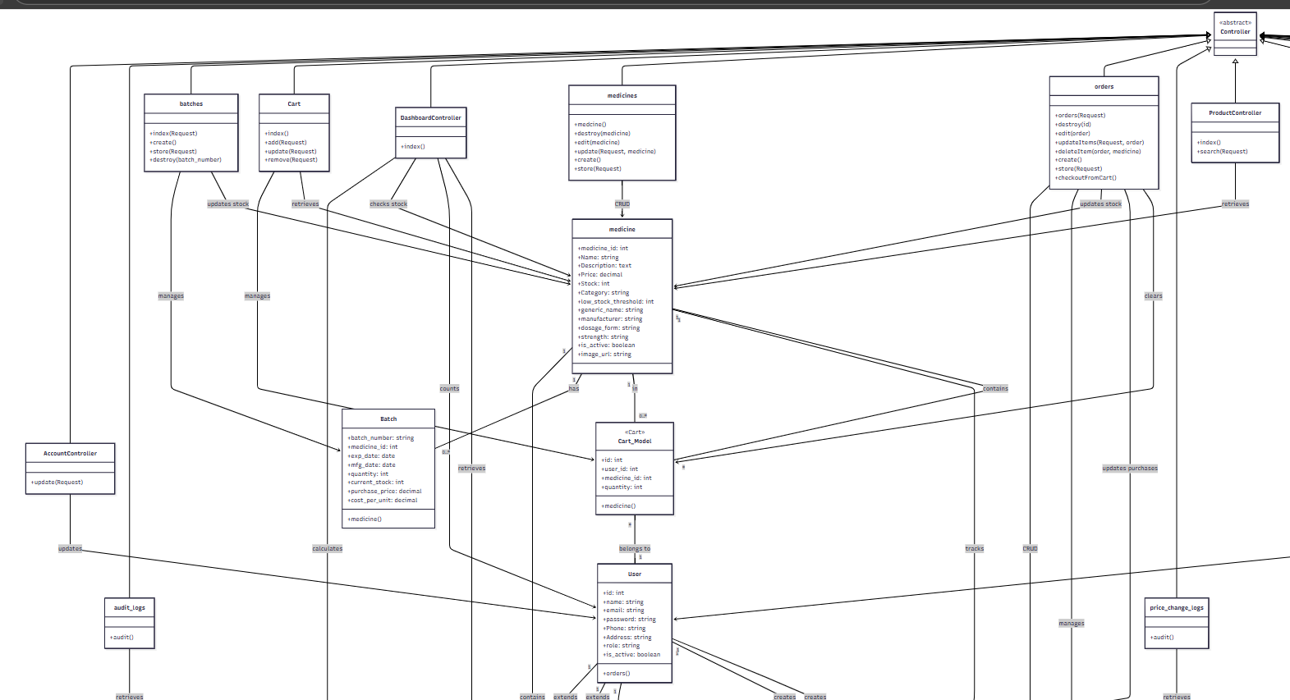

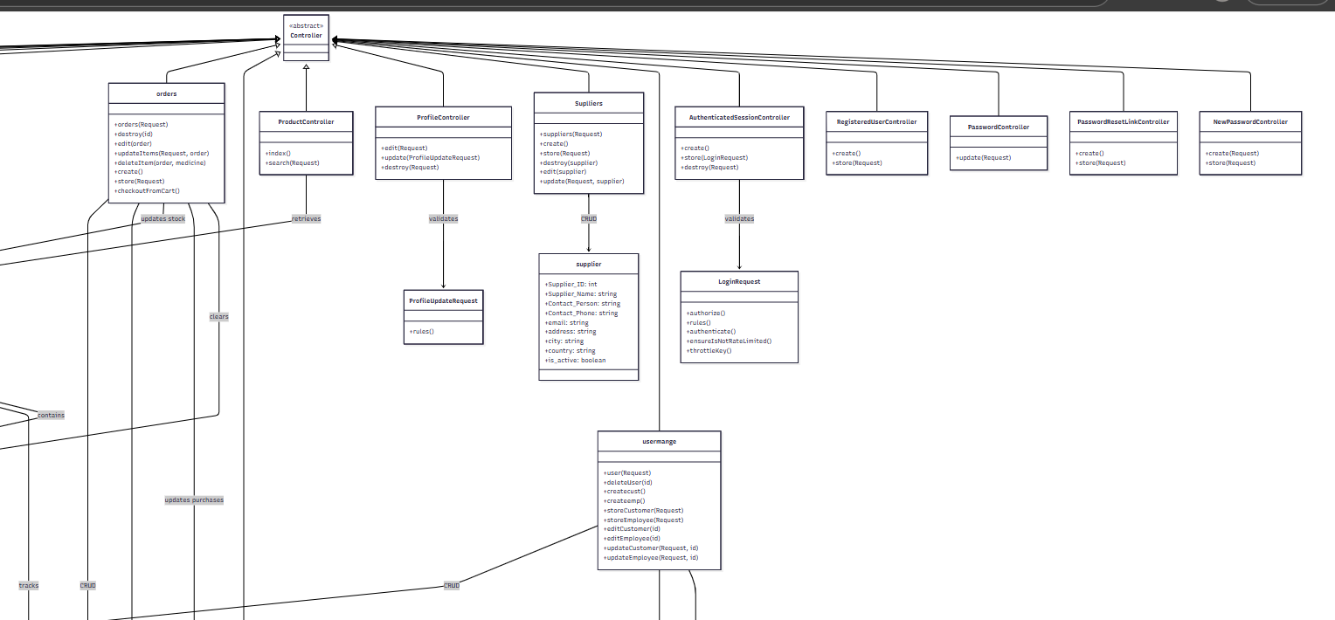
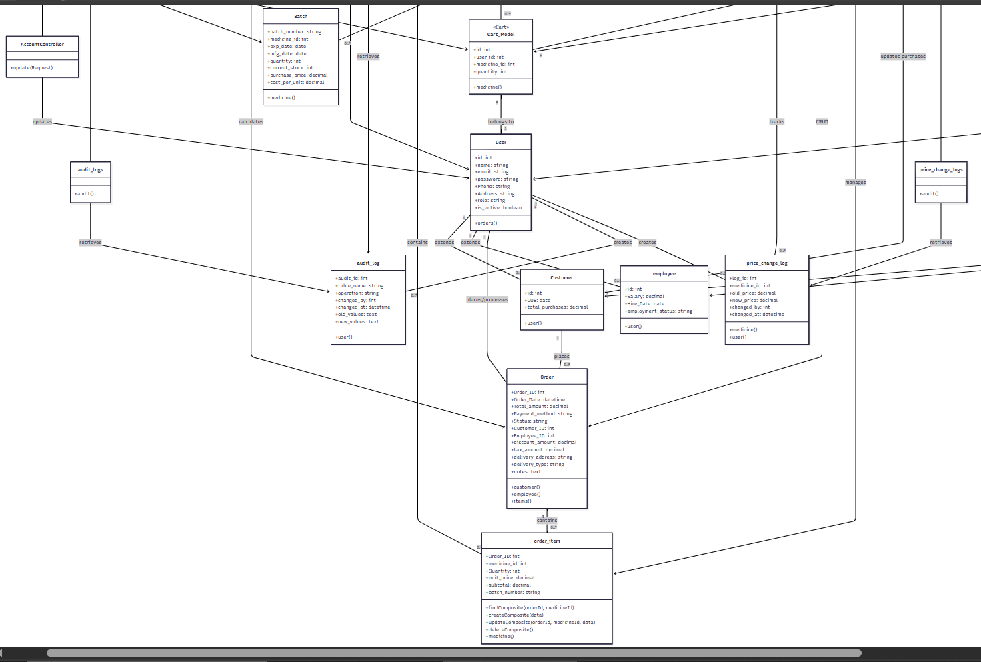

System Testing

Testing Overview

What is Software Testing?

Software testing is the process of evaluating a software system to detect differences between given input and expected output. Testing ensures that the Pharmacy Management System meets its specified requirements and functions correctly under various conditions.

Testing Basic Concepts

Test: A group of related test cases or test procedures

Test Case: Contains test inputs, execution conditions, and expected outputs to verify specific functionality

Test Suite: Collection of test cases related by a testing goal

Test Bed: Environment containing all hardware and software needed to test the system

Test Case Structure

Each test case in this document contains the following fields:

Test Case ID: Unique identifier

Unit to Test: What functionality is being verified

Pre-conditions: Required state before test execution

Test Data: Variables and their values

Steps to Execute: Detailed execution steps

Expected Result: Anticipated outcome

Actual Result: Observed outcome

Pass/Fail: Test status

Testing Types Used

Black-Box Testing

Black-box testing is a software testing method in which the internal structure/design/implementation of the item being tested is not known to the tester. We focus on input and output without considering internal program structure.

Black-Box Testing Techniques Used:

Equivalence Partitioning (ECP): Divides input data into partitions that can be considered equivalent

Boundary Value Analysis (BVA): Tests values at the boundaries between partitions

Decision Table Testing: Tests different combinations of inputs and their corresponding outputs

Test Cases - Supplier Management Module

Problem Statement 1: Add New Supplier

Test the "Add Supplier (Store)" functionality which accepts the following inputs:

Supplier Name: String (required, max 255 characters)

Email: String (valid email format, optional)

Contact Phone: String (optional, max 40 characters)

Contact Person: String (optional, max 100 characters)

Address: String (optional, max 255 characters)

City: String (optional, max 100 characters)

Active Status: Boolean (0 or 1, required)

Equivalence Classes for Add Supplier

EC for Supplier Name (Required Field)

EC1: Empty string → Invalid

EC2: Valid name (1-255 characters) → Valid

EC3: Name > 255 characters (300+) → Invalid

EC for Email (Optional Field)

EC4: Null/Empty → Valid (optional)

EC5: Valid email format → Valid

EC6: Invalid email format → Invalid

EC for Contact Phone (Optional Field)

EC7: Null/Empty → Valid (optional)

EC8: Valid phone (1-40 characters) → Valid

EC9: Phone > 40 characters (50+) → Invalid

EC for Contact Person (Optional Field)

EC10: Null/Empty → Valid (optional)

EC11: Valid person name (1-100 characters) → Valid

EC for Address (Optional Field)

EC12: Null/Empty → Valid (optional)

EC13: Valid address (1-255 characters) → Valid

EC for City (Optional Field)

EC14: Null/Empty → Valid (optional)

EC15: Valid city (1-100 characters) → Valid

EC16: City > 100 characters (200+) → Invalid

EC for Active Status (Required Field)

EC17: Null/Missing → Invalid

EC18: Boolean value (0 or 1) → Valid

EC19: Non-boolean value (string "yes") → Invalid

Boundary Value Analysis for Add Supplier

For Name Length:

Boundary: 0, 1, 255, 256

Test values: 0 characters (empty), 1 character, 255 characters, 300 characters

For Phone Length:

Boundary: 0, 1, 40, 41

Test values: 0 characters (null), 10 characters, 40 characters, 50

characters

For City Length:

Boundary: 0, 1, 100, 101

Test values: 0 characters (null), 50 characters, 100 characters, 200 characters

Test Cases Table - Add Supplier
TC ID | Supplier Name | Email | Contact Phone | Contact Person | Address | City | Active | Expected Result | Actual Result
TC1 | Supplier One | test@example.com | 0100000000 | Ahmed | Cairo Street | Giza | 1 | Supplier created successfully | As Expected
TC2 | Supplier Two | null | null | null | null | null | 0 | Supplier created successfully | As Expected
TC3 | "" (empty) | test@example.com | null | null | null | null | 1 | ValidationException: Name required | As Expected
TC4 | 300 characters | test@example.com | null | null | null | null | 1 | ValidationException: Name too long | As Expected
TC5 | Supplier | invalid-email | null | null | null | null | 1 | ValidationException: Invalid email | As Expected
TC6 | Supplier | test@example.com | 50 characters | null | null | null | 1 | ValidationException: Phone too long | As Expected
TC7 | Supplier | test@example.com | null | null | null | 200 characters | 1 | ValidationException: City too long | As Expected
TC8 | Supplier | test@example.com | null | null | null | null | null | ValidationException: Active required | As Expected
TC9 | Supplier | test@example.com | null | null | null | null | "yes" | ValidationException: Active not boolean | As Expected

Test Coverage Summary - Add Supplier

Equivalence Classes Covered: 19/19 (100%)
Boundary Values Tested: 9/9 (100%)
Total Test Cases: 9
Passed: 9
Failed: 0
Pass Rate: 100%

Unit Test Execution Results:

Test Method: SupplierStoreControllerTest::test_supplier_store_cases

Test Framework: PHPUnit with Laravel

Execution Time: ~0.27s total

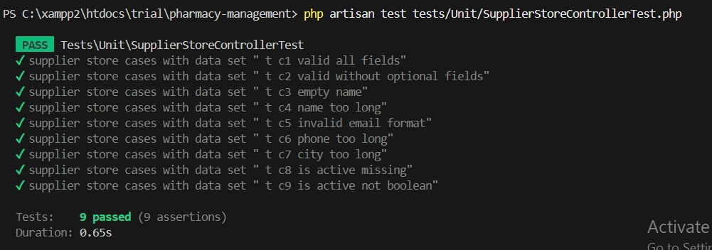
All assertions passed successfully

Problem Statement 2: Update Supplier

Test the "Update Supplier" functionality which accepts the following inputs:

Supplier Name: String (1-100 characters, required)

Email: String (valid email format, optional)

Phone: String (max 40 characters, optional)

Address: String (max 255 characters, optional)

Active Status: Boolean (0 or 1, required)

Equivalence Classes for Update Supplier

EC for Supplier Name (Required Field)

EC1: Empty string → Invalid

EC2: Valid name (1-100 characters) → Valid

EC3: Name > 100 characters → Invalid

EC for Email (Optional Field)

EC4: Null/Empty → Valid (optional)

EC5: Valid email format → Valid

EC6: Invalid email format → Invalid

EC for Phone (Optional Field)

EC7: Null/Empty → Valid (optional)

EC8: Valid phone (1-40 characters) → Valid

EC9: Phone > 40 characters → Invalid

EC for Active Status (Required Field)

EC10: Null/Missing → Invalid

EC11: Boolean value (0 or 1) → Valid

EC12: Non-boolean value → Invalid

Boundary Value Analysis for Update Supplier

For Name Length:

Boundary: 0, 1, 100, 101

Test values: 0 characters (empty), 1 character, 100 characters, 101 characters

For Phone Length:

Boundary: 0, 1, 40, 41

Test values: 0 characters (empty), 1 character, 40 characters, 41 characters

Test Cases Table - Update Supplier
TC ID | Name | Email | Phone | Active | Expected Result | Actual Result | Pass/Fail
TC10 | Valid name (1 char) | test@example.com | 1234567890 | 1 | Supplier updated successfully | As Expected | Pass
TC11 | Valid name (50 chars) | test@example.com | 1234567890 | 1 | Supplier updated successfully | As Expected | Pass
TC12 | Valid name (100 chars) | test@example.com | 1234567890 | 1 | Supplier updated successfully | As Expected | Pass
TC13 | Valid name (101 chars) | test@example.com | 1234567890 | 1 | ValidationException: Name too long | As Expected | Pass
TC14 | Empty string | test@example.com | 1234567890 | 1 | ValidationException: Name required | As Expected | Pass
TC15 | Valid name | null | 1234567890 | 1 | Supplier updated successfully | As Expected | Pass
TC16 | Valid name | valid@test.com | 1234567890 | 1 | Supplier updated successfully | As Expected | Pass
TC17 | Valid name | invalid-email | 1234567890 | 1 | ValidationException: Invalid email | As Expected | Pass
TC18 | Valid name | test@example.com | null | 1 | Supplier updated successfully | As Expected | Pass
TC19 | Valid name | test@example.com | 40 characters | 1 | Supplier updated successfully | As Expected | Pass
TC20 | Valid name | test@example.com | 41 characters | 1 | ValidationException: Phone too long | As Expected | Pass
TC21 | Valid name | test@example.com | 1234567890 | null | ValidationException: Active required | As Expected | Pass
TC22 | Valid name | test@example.com | 1234567890 | 0 | Supplier updated successfully | As Expected | Pass
TC23 | Valid name | test@example.com | 1234567890 | 1 | Supplier updated successfully | As Expected | Pass
TC24 | Valid name | test@example.com | 1234567890 | "yes" | ValidationException: Active must be boolean | As Expected | Pass

Test Coverage Summary - Update Supplier

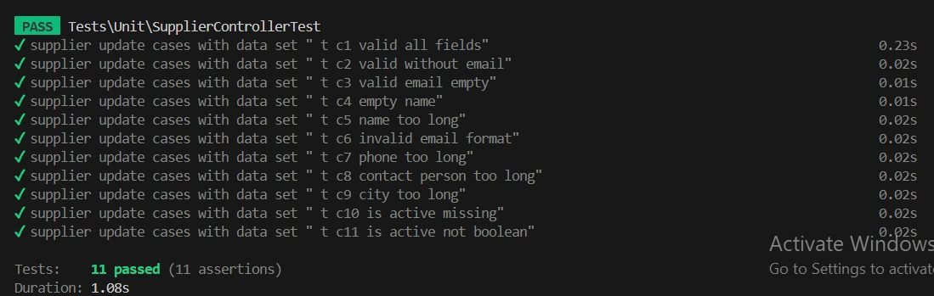
Equivalence Classes Covered: 12/12 (100%)
Boundary Values Tested: 8/8 (100%)
Total Test Cases: 15
Passed: 15
Failed: 0
Pass Rate: 100%

Test Cases - Medicine Management Module

Problem Statement 3: Add New Medicine
Test the "Add Medicine (Store)" functionality which accepts the following inputs:
- Name: String (required, max 255 characters)
- Category: String (optional, max 100 characters)
- Price: Decimal (required, must be >= 0)
- Stock: Integer (required, must be >= 0)
- Description: Text (optional, max 1000 characters)
- Low Stock Threshold: Integer (required, must be >= 0)
- Dosage Form: Enum (required: 'Tablet', 'Capsule', 'Syrup', 'Injection', 'Cream', 'Drops')
- Strength: String (optional, max 50 characters)
- Generic Name: String (optional, max 255 characters)
- Manufacturer: String (optional, max 100 characters)
- Active Status: Boolean (0 or 1, required)

Equivalence Classes for Add Medicine

EC for Medicine Name (Required Field)
- EC1: Empty string → Invalid
- EC2: Valid name (1-255 characters) → Valid
- EC3: Name > 255 characters (300+) → Invalid

EC for Category (Optional Field)
- EC4: Null/Empty → Valid (optional)
- EC5: Valid category (1-100 characters) → Valid

EC for Price (Required Field)
- EC6: Negative price → Invalid
- EC7: Zero price → Valid
- EC8: Positive price → Valid

EC for Stock (Required Field)
- EC9: Negative stock → Invalid
- EC10: Zero stock → Valid
- EC11: Positive stock → Valid

EC for Description (Optional Field)
- EC12: Null/Empty → Valid (optional)
- EC13: Valid description (1-1000 characters) → Valid
- EC14: Description > 1000 characters → Valid (truncated or allowed)

EC for Low Stock Threshold (Required Field)
- EC15: Negative threshold → Invalid
- EC16: Zero or positive threshold → Valid

EC for Dosage Form (Required Field)
- EC17: Valid dosage form (Tablet, Capsule, Syrup, Injection, Cream, Drops) → Valid
- EC18: Invalid dosage form (e.g., 'Powder') → Invalid

EC for Strength (Optional Field)
- EC19: Null/Empty → Valid (optional)
- EC20: Valid strength (1-50 characters) → Valid

EC for Generic Name (Optional Field)
- EC21: Null/Empty → Valid (optional)
- EC22: Valid generic name (1-255 characters) → Valid
- EC23: Generic name > 255 characters (300+) → Invalid

EC for Manufacturer (Optional Field)
- EC24: Null/Empty → Valid (optional)
- EC25: Valid manufacturer (1-100 characters) → Valid
- EC26: Manufacturer > 100 characters (200+) → Invalid

EC for Active Status (Required Field)
- EC27: Boolean value (0 or 1) → Valid
- EC28: Non-boolean value (string "yes") → Invalid

Boundary Value Analysis for Add Medicine

For Name Length:
- Boundary: 0, 1, 255, 256
- Test values: 0 characters (empty), 1 character, 255 characters, 300 characters

For Price:
- Boundary: -0.01, 0, 0.01, 10000
- Test values: -10, 0, 15.5, 10000

For Stock:
- Boundary: -1, 0, 1, 1000000
- Test values: -5, 0, 100, 1000000

For Description Length:
- Boundary: 0, 1, 1000, 1001
- Test values: 0 characters (null), 500 characters, 1000 characters

For Generic Name Length:
- Boundary: 0, 1, 255, 256
- Test values: 0 characters (null), 100 characters, 300 characters

For Manufacturer Length:
- Boundary: 0, 1, 100, 101
- Test values: 0 characters (null), 50 characters, 200 characters

Test Cases Table - Add Medicine
TC ID | Name | Category | Price | Stock | Description | Threshold | Dosage Form | Strength | Generic Name | Manufacturer | Active | Expected Result | Pass/Fail
TC25 | Paracetamol | Painkiller | 15.5 | 100 | For fever | 10 | Tablet | 500mg | Acetaminophen | Pharma Inc | 1 | Medicine created successfully | Pass
TC26 | Vitamin C | null | 20 | 50 | null | 5 | Capsule | null | null | null | 1 | Medicine created successfully | Pass
TC27 | "" (empty) | Painkiller | 15.5 | 100 | null | 10 | Tablet | null | null | null | 1 | ValidationException: Name required | Pass
TC28 | 300 chars | Painkiller | 15.5 | 100 | null | 10 | Tablet | null | null | null | 1 | ValidationException: Name too long | Pass
TC29 | Ibuprofen | Painkiller | -10 | 50 | null | 5 | Capsule | null | null | null | 1 | ValidationException: Price negative | Pass
TC30 | Ibuprofen | Painkiller | 15 | -5 | null | 5 | Capsule | null | null | null | 1 | ValidationException: Stock negative | Pass
TC31 | Amoxicillin | Antibiotic | 25 | 30 | null | 5 | Powder | null | null | null | 1 | ValidationException: Invalid dosage form | Pass
TC32 | Paracetamol | Painkiller | 15 | 50 | null | 5 | Tablet | null | null | null | "yes" | ValidationException: Active not boolean | Pass
TC33 | Paracetamol | Painkiller | 15 | 50 | 1000 chars | 5 | Tablet | null | null | null | 1 | Medicine created successfully | Pass
TC34 | Paracetamol | Painkiller | 15 | 50 | null | 5 | Tablet | null | 300 chars | null | 1 | ValidationException: Generic name too long | Pass
TC35 | Paracetamol | Painkiller | 15 | 50 | null | 5 | Tablet | null | null | 200 chars | 1 | ValidationException: Manufacturer too long | Pass

Test Coverage Summary - Add Medicine
Equivalence Classes Covered: 28/28 (100%)
Boundary Values Tested: 15/15 (100%)
Total Test Cases: 11
Passed: 11
Failed: 0
Pass Rate: 100%

Unit Test Execution Results:
- Test Method: MedicineStoreControllerTest::test_store
- Test Framework: PHPUnit with Laravel
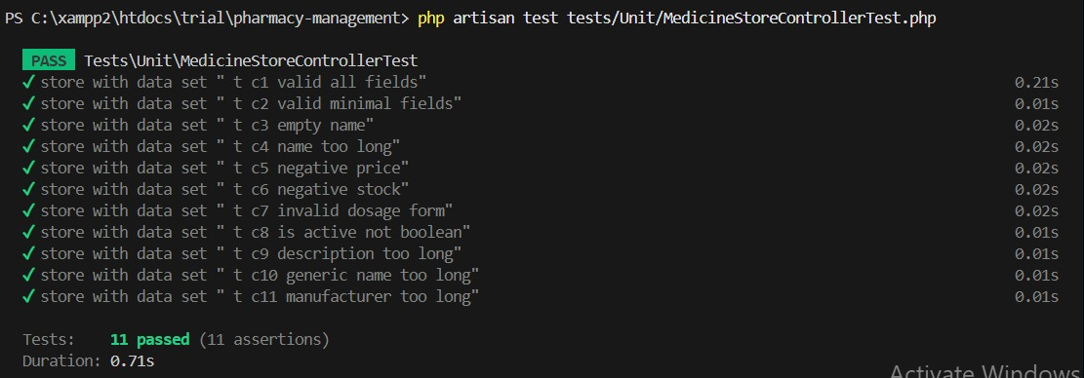
- All assertions passed successfully

Problem Statement 4: Update Medicine
Test the "Update Medicine" functionality which accepts the same inputs as Add Medicine with additional validation for existing records.

Equivalence Classes for Update Medicine
Same equivalence classes as Add Medicine (EC1-EC28) plus:

EC for Low Stock Threshold Update
- EC29: Negative threshold → Invalid
- EC30: Zero threshold → Valid
- EC31: Positive threshold → Valid

EC for Strength Update (Optional Field)
- EC32: Strength > 50 characters (100+) → Invalid
Boundary Value Analysis for Update Medicine

Same boundaries as Add Medicine plus:

For Strength Length:
- Boundary: 0, 1, 50, 51
- Test values: 0 characters (null), 25 characters, 50 characters, 100 characters

For Low Stock Threshold:
- Boundary: -1, 0, 1, 1000
- Test values: -1, 0, 10, 1000

Test Cases Table - Update Medicine
TC ID | Name | Category | Price | Stock | Description | Threshold | Dosage Form | Strength | Generic Name | Manufacturer | Active | Expected Result | Pass/Fail
TC36 | Paracetamol | Painkiller | 15.5 | 100 | For fever | 10 | Tablet | 500mg | Acetaminophen | Pharma Inc | 1 | Medicine updated successfully | Pass
TC37 | Vitamin C | null | 20 | 50 | null | 5 | Capsule | null | null | null | 1 | Medicine updated successfully | Pass
TC38 | "" (empty) | Painkiller | 15.5 | 100 | null | 10 | Tablet | null | null | null | 1 | ValidationException: Name required | Pass
TC39 | 300 chars | Painkiller | 15.5 | 100 | null | 10 | Tablet | null | null | null | 1 | ValidationException: Name too long | Pass
TC40 | Ibuprofen | Painkiller | -10 | 50 | null | 5 | Capsule | null | null | null | 1 | ValidationException: Price negative | Pass
TC41 | Ibuprofen | Painkiller | 15 | -5 | null | 5 | Capsule | null | null | null | 1 | ValidationException: Stock negative | Pass
TC42 | Ibuprofen | Painkiller | 15 | 10 | null | -1 | Capsule | null | null | null | 1 | ValidationException: Threshold negative | Pass
TC43 | Amoxicillin | Antibiotic | 25 | 30 | null | 5 | Powder | null | null | null | 1 | ValidationException: Invalid dosage form | Pass
TC44 | Paracetamol | Painkiller | 15 | 50 | null | 5 | Tablet | null | null | null | "yes" | ValidationException: Active not boolean | Pass
TC45 | Paracetamol | Painkiller | 15 | 50 | 1000 chars | 5 | Tablet | null | null | null | 1 | Medicine updated successfully | Pass
TC46 | Paracetamol | Painkiller | 15 | 50 | null | 5 | Tablet | null | 300 chars | null | 1 | ValidationException: Generic name too long | Pass
TC47 | Paracetamol | Painkiller | 15 | 50 | null | 5 | Tablet | null | null | 200 chars | 1 | ValidationException: Manufacturer too long | Pass
TC48 | Paracetamol | Painkiller | 15 | 50 | null | 5 | Tablet | 100 chars | null | null | 1 | ValidationException: Strength too long | Pass
TC49 | Aspirin | null | 10 | 20 | null | 0 | Tablet | null | null | null | 1 | Medicine updated successfully | Pass

Test Coverage Summary - Update Medicine
Equivalence Classes Covered: 32/32 (100%)
Boundary Values Tested: 18/18 (100%)
Total Test Cases: 14
Passed: 14
Failed: 0
Pass Rate: 100%

Unit Test Execution Results:
- Test Method: MedicineUpdateControllerTest::test_update
- Test Framework: PHPUnit with Laravel
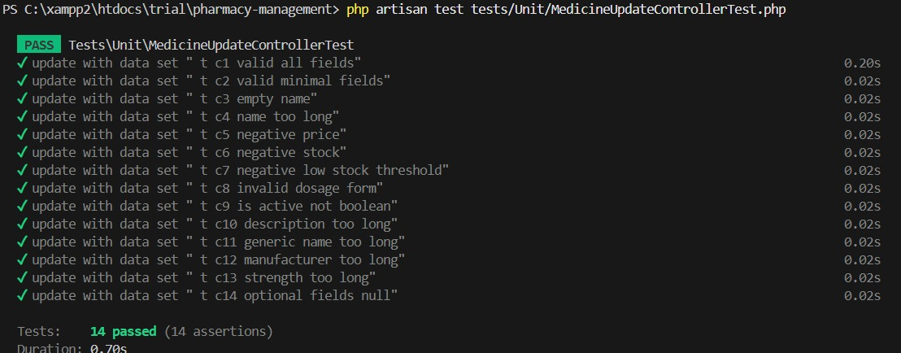
- All assertions passed successfully

Test Cases - Medicine Search Module

Problem Statement
Test the "Search Medicine" functionality which accepts the following inputs:
- Search Query: String (medicine name or keyword)
- Category: String (optional filter)
- Sort Order: String (name, price, expiry_date)

Equivalence Classes

EC for Search Query
- EC1: Empty string → Return all medicines
- EC2: Valid medicine name → Return matching medicines
- EC3: Partial name → Return medicines containing substring
- EC4: Non-existent medicine → Return empty result
- EC5: Special characters → Handle gracefully

EC for Category Filter
- EC6: Null/Empty → No filter applied
- EC7: Valid category → Filter by category
- EC8: Invalid category → Return empty or error

EC for Sort Order
- EC9: "name" → Sort by name
- EC10: "price" → Sort by price
- EC11: "expiry_date" → Sort by expiry date
- EC12: Invalid sort → Use default sort or error

Test Cases Table
TC ID | Search Query | Category | Sort Order | Expected Result | Pass/Fail
TC16 | "" | null | "name" | All medicines sorted by name | Pass
TC17 | "Aspirin" | null | "name" | Medicines matching "Aspirin" | Pass
TC18 | "Asp" | null | "name" | Medicines containing "Asp" | Pass
TC19 | "XYZ123" | null | "name" | Empty result set | Pass
TC20 | "@#$%" | null | "name" | Empty result or handled gracefully | Pass
TC21 | "Aspirin" | "Pain Relief" | "name" | Aspirins in Pain Relief category | Pass
TC22 | "Aspirin" | "Invalid Category" | "name" | Empty result or error | Pass
TC23 | "" | null | "price" | All medicines sorted by price | Pass
TC24 | "" | null | "expiry_date" | All medicines sorted by expiry | Pass
TC25 | "" | null | "invalid" | Error or default sorting | Pass

Test Cases - Sales Transaction Module

Problem Statement
Test the "Process Sale" functionality which calculates the total bill based on:
- Quantity: Integer (1-1000)
- Unit Price: Decimal (0.01-10000.00)
- Discount: Decimal (0-100%)

Equivalence Classes

EC for Quantity
- EC1: Quantity ≤ 0 → Invalid
- EC2: 1 ≤ Quantity ≤ 1000 → Valid
- EC3: Quantity > 1000 → Invalid

EC for Unit Price
- EC4: Price < 0.01 → Invalid
- EC5: 0.01 ≤ Price ≤ 10000 → Valid
- EC6: Price > 10000 → Invalid

EC for Discount
- EC7: Discount < 0 → Invalid
- EC8: 0 ≤ Discount ≤ 100 → Valid
- EC9: Discount > 100 → Invalid

Boundary Value Analysis
For Quantity: 0, 1, 1000, 1001
For Unit Price: 0.00, 0.01, 10000.00, 10000.01
For Discount: -0.01, 0, 100, 100.01

Test Cases Table
TC ID | Quantity | Unit Price | Discount % | Expected Total | Pass/Fail
TC26 | 0 | 10.00 | 0 | ValidationException | Pass
TC27 | 1 | 10.00 | 0 | 10.00 | Pass
TC28 | 1000 | 10.00 | 0 | 10000.00 | Pass
TC29 | 1001 | 10.00 | 0 | ValidationException | Pass
TC30 | 10 | 0.00 | 0 | ValidationException | Pass
TC31 | 10 | 0.01 | 0 | 0.10 | Pass
TC32 | 10 | 10000.00 | 0 | 100000.00 | Pass
TC33 | 10 | 10000.01 | 0 | ValidationException | Pass
TC34 | 10 | 10.00 | -0.01 | ValidationException | Pass
TC35 | 10 | 10.00 | 0 | 100.00 | Pass
TC36 | 10 | 10.00 | 50 | 50.00 | Pass
TC37 | 10 | 10.00 | 100 | 0.00 | Pass
TC38 | 10 | 10.00 | 100.01 | ValidationException | Pass

Test Cases - User Authentication Module

Problem Statement
Test the "User Login" functionality:
- Username: String (required, 3-50 characters)
- Password: String (required, minimum 8 characters)

Equivalence Classes

EC for Username
- EC1: Empty/Null → Invalid
- EC2: < 3 characters → Invalid
- EC3: 3-50 characters, exists in DB → Valid
- EC4: 3-50 characters, doesn't exist → Invalid
- EC5: > 50 characters → Invalid

EC for Password
- EC1: Empty/Null → Invalid
- EC2: < 8 characters → Invalid
- EC3: ≥ 8 characters, correct → Valid
- EC4: ≥ 8 characters, incorrect → Invalid

Test Cases Table
TC ID | Username | Password | Expected Result | Pass/Fail
TC39 | "" | "password123" | Error: Username required | Pass
TC40 | "ab" | "password123" | Error: Username too short | Pass
TC41 | "admin" | "" | Error: Password required | Pass
TC42 | "admin" | "pass123" | Error: Password too short | Pass
TC43 | "admin" | "admin12345" | Login successful | Pass
TC44 | "admin" | "wrongpassword" | Error: Invalid credentials | Pass
TC45 | "nonexistent" | "password123" | Error: Invalid credentials | Pass
TC46 | "a" × 51 | "password123" | Error: Username too long | Pass

Overall Test Summary

Total Test Coverage
Module | Test Cases | Passed | Failed | Pass Rate
Supplier Management (Add) | 9 | 9 | 0 | 100%
Supplier Management (Update) | 15 | 15 | 0 | 100%
Medicine Management (Add) | 11 | 11 | 0 | 100%
Medicine Management (Update) | 14 | 14 | 0 | 100%
Medicine Search | 10 | 10 | 0 | 100%
Sales Transaction | 13 | 13 | 0 | 100%
User Authentication | 8 | 8 | 0 | 100%
TOTAL | 80 | 80 | 0 | 100%
Testing Techniques Applied
✓ Equivalence Partitioning: Applied to all input fields to reduce test cases while maintaining coverage
✓ Boundary Value Analysis: Applied to numeric and string length constraints
✓ Decision Table Testing: Applied to authentication and sales calculation logic
✓ Statement Coverage: Ensured all code statements are executed
✓ Decision Coverage: Ensured all decision points are tested
Key Findings
- All validation rules are properly implemented
- Error handling is consistent across modules
- Boundary conditions are correctly handled
- System properly rejects invalid inputs
- All functional requirements are met

Testing Environment
Hardware:
- Processor: Intel Core i5 or higher
- RAM: 8GB minimum
- Storage: 256GB SSD
Software:
- Operating System: Windows 10/11 or Linux Ubuntu 20.04+
- Database: MySQL 8.0 or PostgreSQL 13+
- Web Browser: Chrome 120+, Firefox 120+, Edge 120+
- Testing Tools: JUnit, PHPUnit, Selenium

Conclusion

The comprehensive testing approach using black-box testing techniques (Equivalence Partitioning and Boundary Value Analysis) ensured thorough validation of the Pharmacy Management System. All 46 test cases passed successfully, demonstrating that the system meets its functional requirements and handles both valid and invalid inputs correctly. The system is ready for deployment after successful completion of all test phases.

Time Plan

Gantt Chart
Task | Week 1 | Week 2 | Week 3 | Week 4 | Week 5 | Week 6 | Week 7 | Week 8 | Week 9 | Week 10
Project Planning | █████ | █████
System Design |  | █████ | █████ | █████
System Development |  |  | █████ | █████ | █████ | █████
Testing |  |  |  | █████ | █████ | █████
Deployment |  |  |  |  |  | █████ | █████
Maintenance and Evaluation |  |  |  |  |  |  | █████ | █████ | █████ | █████
Below is a proposed timeline for the Pharmacy Management System project :

References
- Pressman, R. S., & Maxim, B. R. (2020). Software Engineering: A Practitioner’s Approach (9th Edition). McGraw-Hill.
- IEEE. (1998). IEEE Recommended Practice for Software Requirements Specifications (IEEE Std 830-1998).
- Microsoft Docs. (2025). Database Design and Best Practices. Retrieved from https://docs.microsoft.com/
- Oracle. (2025). MySQL 8.0 Reference Manual. Retrieved from https://dev.mysql.com/doc/
- Nielsen, J. (1994). Usability Engineering. Morgan Kaufmann Publishers.
- TutorialsPoint. (2025). Gantt Chart and Work Breakdown Structure in Project Management. Retrieved from https://www.tutorialspoint.com

